Example 1: Rolling up the non-threatened side

The following iron condor was started on October 8th with RUT trading at around 1050.

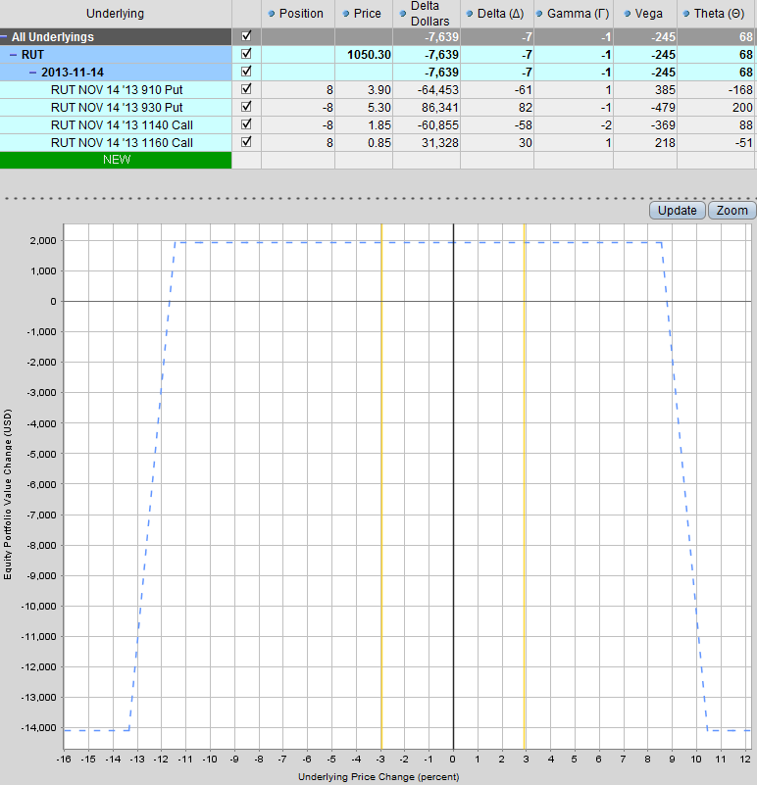

Three days later, RUT had risen to 1084 resulting in our position being skewed. Our short puts were 14% away from the current price, but our short calls were only 5.5% away. All of our risk parameters were ok, the delta of the short calls was below 0.20. Our delta dollar exposure was at $46,000 which was getting close to our limit.

We rolled the put spread up from 930-910 to 970-950. We closed the 930-910 spread for $0.55 and opened the new spread at $0.94. With 8 contracts, that resulted in an additional $312 in income potential for the trade. Our delta exposure was reduced from -43 (or -$46,350) to -33 ($-35,615).

Our short puts were now around 10% out of the money and out short calls were still 5.5% away. The position was still skewed slightly with negative delta, but less than it was before.

BEFORE ADJUSTMENT

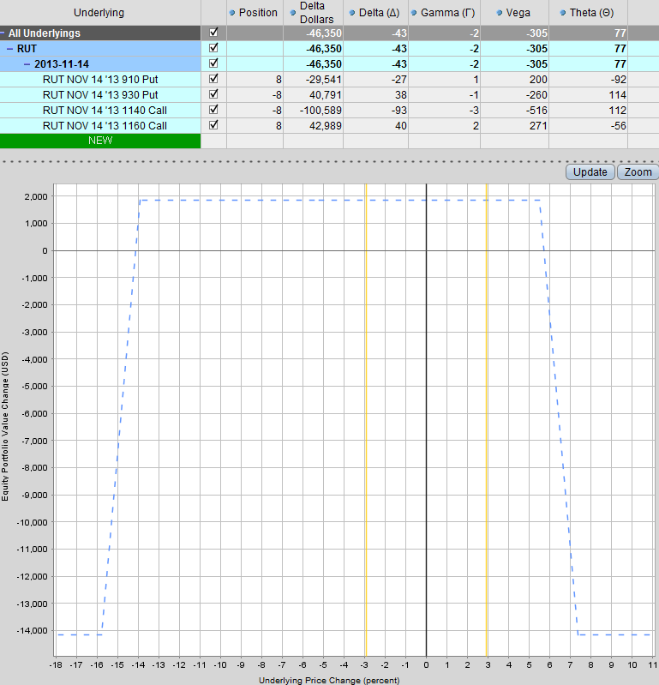

AFTER ADJUSTMENT

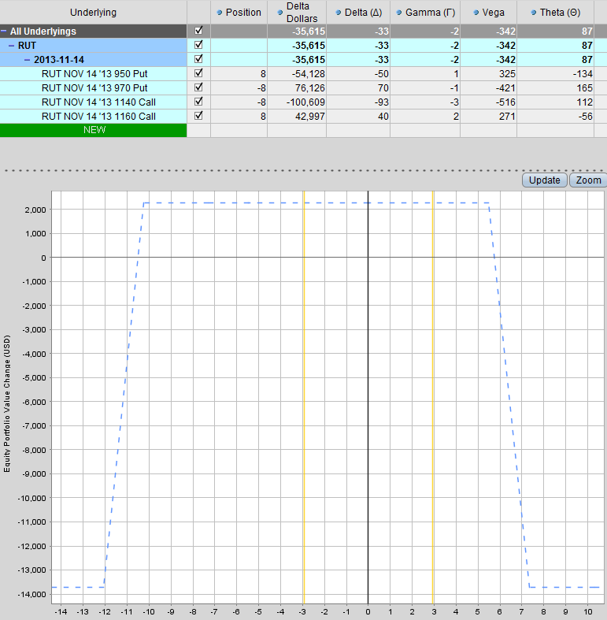

Example 1: Pros and Cons and When to Use

- PROS
  - Delta is reduced
  - More income potential in the trade

- CONS
  - Short strikes are now closer to the money
  - Delta is reduced, but not by a huge amount. A further rally could hurt the position

- When to Use?
  - Early on in the trade if most of the risk parameters on the threatened side are ok

Example 1a: Rolling the non-threatened side closer to the money
This is another example of rolling up the non-threatened. The following is a Dec 19th iron condor as of October 31st. We will use this position for the remaining examples. The position started with half the allowable position size (10 of a possible 20 contracts). The delta has become skewed and sitting at -45 or -$50,084. The short calls are ok to leave where they are more than 3% away from the current price and delta is only at 0.15.
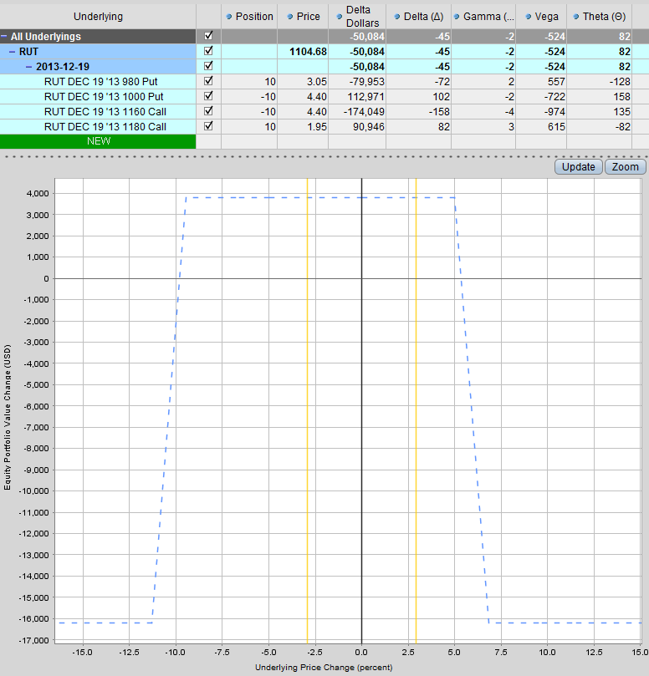

By rolling the short puts up from 1000-980 to 1030-1010, we have reduced delta from -45 to -34 while also bringing in an extra $550 in income. Capital at risk is more or less the same (decreases by the $550 income received). Vega has increased slightly and Theta is the same. Our short puts are 7% from the index price and our short calls are 5% away.
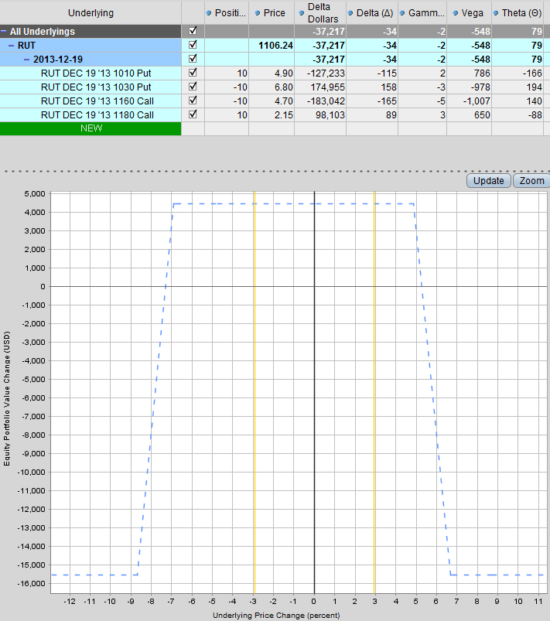
Example 2: Adding contracts to the non-threatened side

Rolling the short puts up might be a bit aggressive considering that the market is overbought and starting to show weakness. What we can do in this case, is go to our full allocation of 20 contracts in the puts and leave the calls as they are. This increases capital at risk on the downside, but gets our delta back into line. Vega has increased from -524 to -688 and Theta has also increased from 82 to 112. The Vega/Theta ratio has dropped slightly from 639% to 614%. By selling another 10 put credit spreads, we have increased the profit potential by $1,350
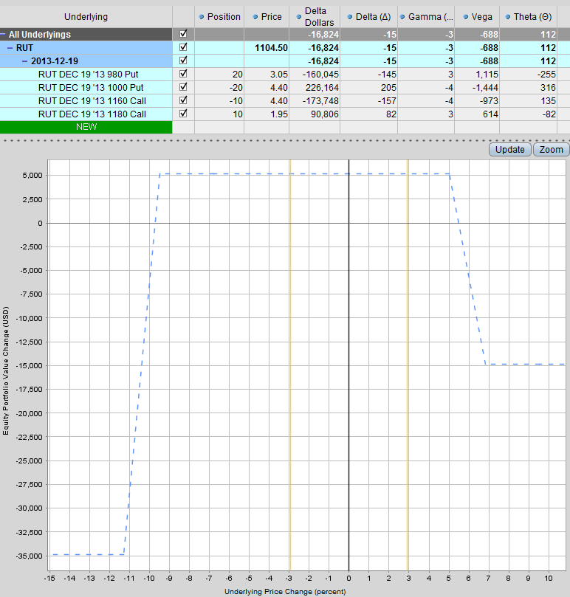

Example 2: Pros and Cons and When to Use

- PROS
  - Delta is significantly reduced
  - More income potential in the trade

- CONS
  - Capital at risk on the downside has doubled
  - Higher Vega exposure (although Vega/Theta ratio has been reduced slightly)

- When to Use?
  - Early on in the trade as you are building up to your full allocation

Example 3: Adding a debit spread to create a “cat ear”

The first two examples of rolling up the short puts and adding more contracts, would be considered aggressive or attacking adjustments. Both methods increased the income received. The first method moved the short strikes closer and the second method increased capital at risk. A more defensive adjustment would be to add a call debit spread (bull call spread) on the upside. Using the short strike of the credit spread as the short strike of the debit spread, results in a “cat ear” profit zone.

Unlike the first two adjustments, this method costs us money to buy the debit spread. As such, it actually reduces our capital at risk on the call side. The adjustment costs $880 and results in delta dropping from -45 to -24. Vega has been reduced from -524 to -454 but Theta has also been reduced from 82 to 71. The Vega/Theta ratio remains the same at 639%.

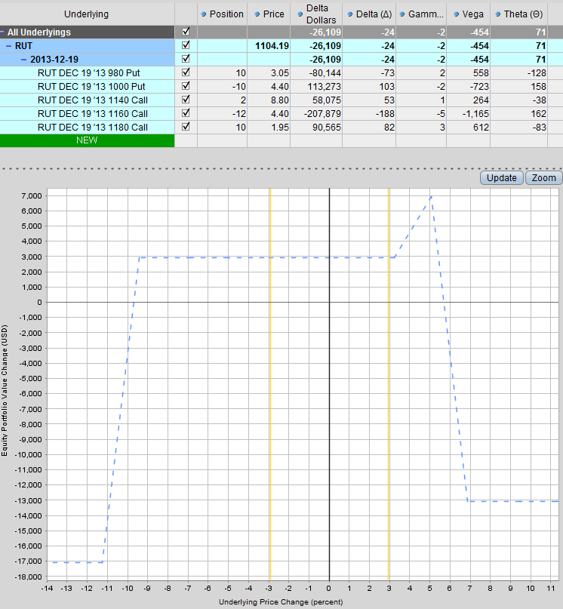

Example 3: Pros and Cons and When to Use

- PROS
  - Nice way to reduce delta and also reduce Vega.
  - Reduces capital at risk on the threatened side
  - Allows you to stay in the position and not move your short strikes
  - Potential for the stock or index to close in the profit zone (although unlikely)

- CONS
  - The adjustment costs you money to make it, reducing the income potential from the trade
  - You can get “sucked in” by the profit zone

- When to Use?
  - When the market is overextended, mainly on the upside. When the chances of a correction are high and it doesn’t make sense to increase risk on the put side.
  - When volatility is low, this can be a good adjustment on the call side as the debit spread will be cheaper.

Example 4: Adding a debit spread to create a larger profit zone

This adjustment is similar to the “cat ear”, but we are creating a larger profit zone for price to potentially end up in. You have to be careful with this not to get sucked into thinking about the profit zone, you still have negative delta, so you do not want RUT to rally, especially in the next few days. You only want RUT to start entering the profit zone with 7 days till expiry or less. Greeks are fairly similar to the car ear. This adjustment costs slightly more.
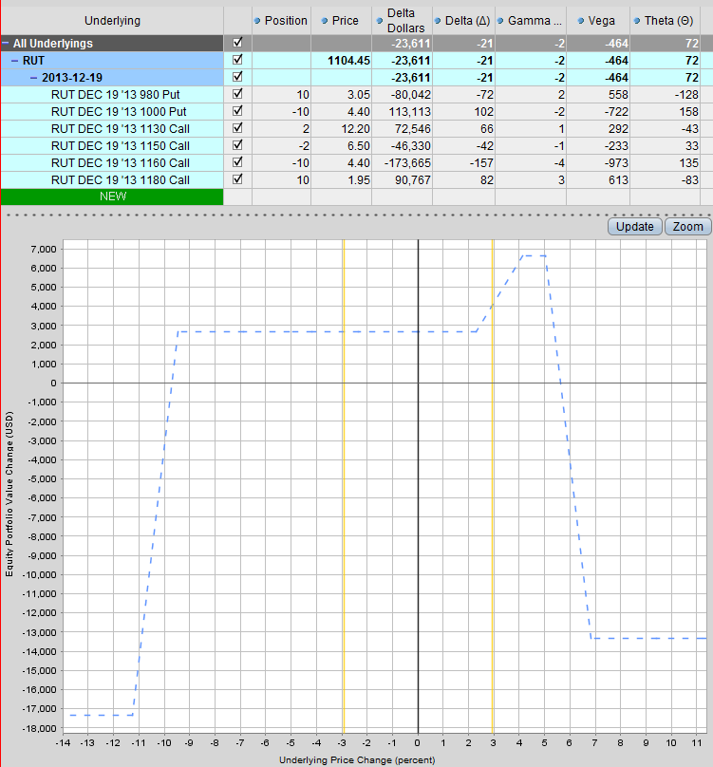

Example 4: Pros and Cons and When to Use

- PROS
  - Nice way to reduce delta and also reduce Vega.
  - Reduces capital at risk on the threatened side
  - Allows you to stay in the position and not move your short strikes
  - Potential for the stock or index to close in the profit zone (although unlikely)

- CONS
  - The adjustment costs you money to make it, reducing the income potential from the trade
  - You can get “sucked in” by the profit zone

- When to Use?
  - When the market is overextended, mainly on the upside. When the chances of a correction are high and it doesn’t make sense to increase risk on the put side.
  - When volatility is low, this can be a good adjustment on the call side as the debit spread will be cheaper.

Example 5: Adding a long call in the next expiry month, same strike as short calls

Adding a long call is generally used as a temporary measure to control delta. In this example you can see delta has dropped to -22 with the added benefit of Vega dropping to -370. There is also a nice potential profit zone on the upside. Capital at risk on the upside has been reduced.

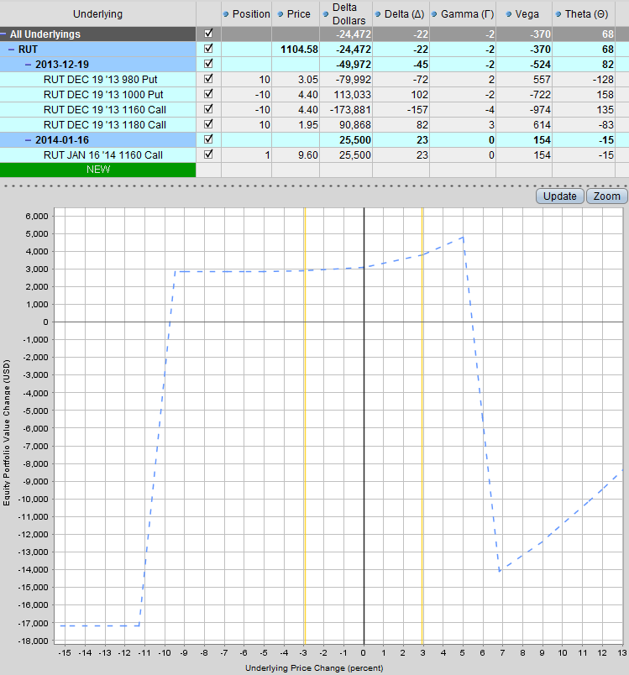

Example 5: Pros and Cons and When to Use

- PROS
  - Gives a much greater reduction in short Vega, which can be good if you expect a rise in volatility.
  - Reduces capital at risk on the threatened side
  - Allows you to stay in the position and not move your short strikes
  - Nicely sloping profit graph if the market continues to trend
  - Easy adjustment to make and manage

- CONS
  - The adjustment costs you money to make it, reducing the income potential from the trade
  - Can be expensive

- When to Use?
  - When volatility is low as the long call will be cheaper
  - When the market is moving fast and you need to quickly cut delta

Example 6: Adding a long call in the next expiry month, same strike as long calls

Similar to the last example, except we are placing the long call further out which costs less but also reduces Delta and Vega by less.

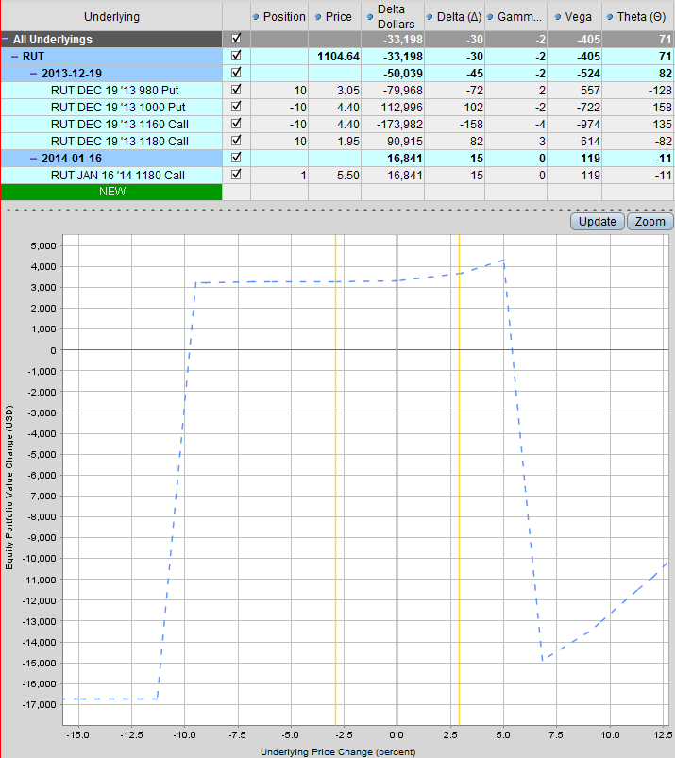
Example 6: Pros and Cons and When to Use

- PROS
  - Gives a much greater reduction in short Vega, which can be good if you expect a rise in volatility.
  - Reduces capital at risk on the threatened side
  - Allows you to stay in the position and not move your short strikes
  - Nicely sloping profit graph if the market continues to trend
  - Easy adjustment to make and manage
  - Cheaper than the previous example and the long call is further out-of-the-money

- CONS
  - The adjustment costs you money to make it, reducing the income potential from the trade
  - Can be expensive
  - Provides less protection than a closer to the money long call

- When to Use?
  - When volatility is low as the long call will be cheaper
  - When the market is moving fast and you need to quickly cut delta

Example 7: Adding a call calendar spread centered at the short call strike

Adding some calendar spreads around the short call strike reduces Delta, reduces Vega and increases Theta so this can be an attractive adjustment option. The downside is that the income potential on the downside is greatly reduced.
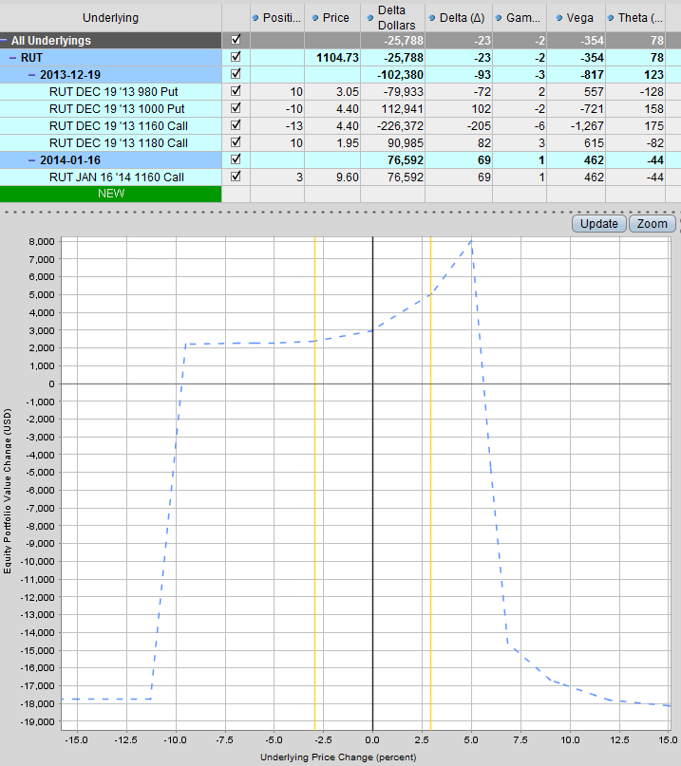
Example 7: Pros and Cons and When to Use

- PROS
  - Very nice profit zone if the market continues to trend
  - Cuts Delta and Vega exposure while also increasing Theta

- CONS
  - Can be expensive and cut into the income if the market reverses

- When to Use?
  - If you think the stock or index will finish around the short strike
  - When volatility is low and you are expecting an increase

Example 8: Adding a call butterfly spread centered at the short call strike

This adjustment creates a profit zone similar to adding a calendar, however Vega is not reduced. Keeping the strikes in the same expiry month can make things a little easier to manage.
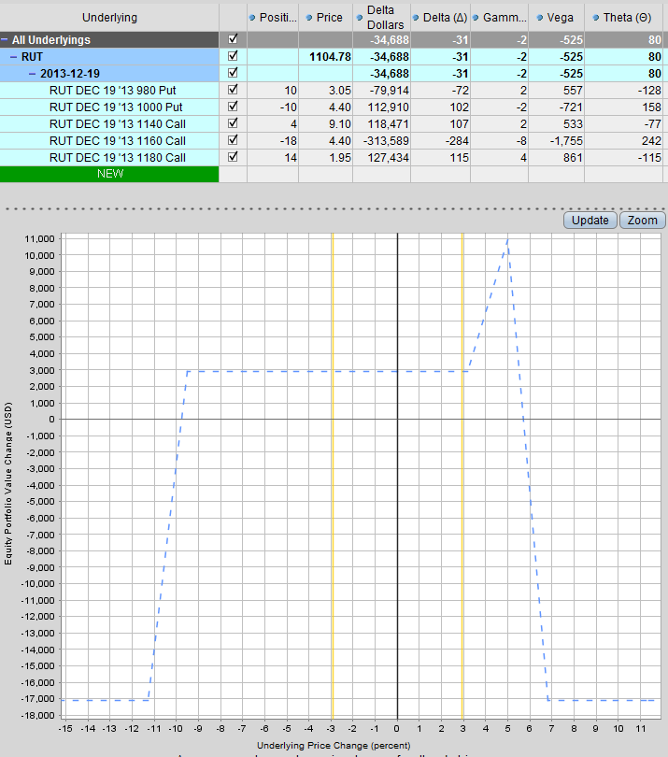

Example 8: Pros and Cons and When to Use

- PROS
  - Creates a profit zone around the short strikes
  - Easier to manage with all strikes in the same expiry month
  - Maintains short Vega exposure which may be good if volatility is high and expected to come down

- CONS
  - Does not reduce Vega
  - The profit zone can create a false sense of security. If the market continues to trend strongly and gets in to the profit zone too early, you will still have losses.

- When to Use?
  - When volatility is high, so may be better used when the puts are under pressure

Example 9: Rolling both the put spreads and call spreads up

This adjustment costs around $400 and repositions the entire condor to be more central. Distance to the short puts is now -6.79% and short calls is 5.88%.
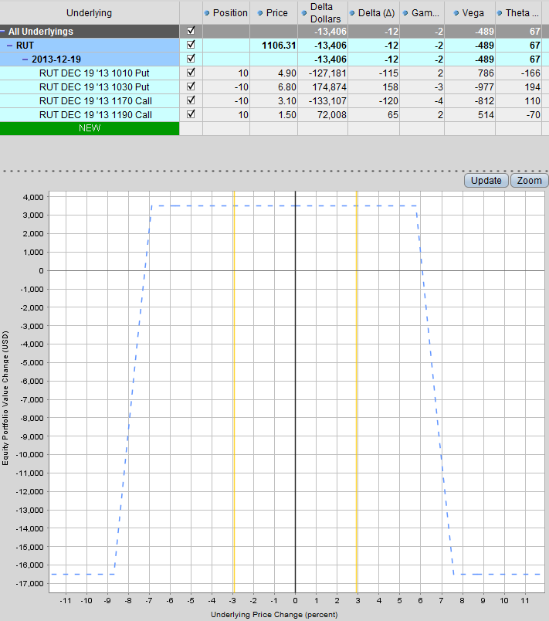
Example 9: Pros and Cons and When to Use

- PROS
  - Gets you back close to delta neutral and better aligned with the short calls and puts
  - Not too expensive (if the market hasn’t moved too far) as the loss on one side will be somewhat covered by the increased income on the other side.
  - Can be a good opportunity to add capital to the trade, further decreasing the cost

- CONS
  - Sometimes it can be better to wait for the market to revert to the mean, rather than repositioning

- When to Use?
  - If the stock or index has broken out of a trading range

SUMMARY

